# How to Create a Flare Tooltip Topic for Volusion

If you have configured everything you need in Flare, or have loaded a Flare project with all settings and content, you can begin creating tooltips! The process includes creating and writing your tooltips, assigning the masterpage, and assigning the alias.

**Note:** Alias assignments may wait until Dev has a clear process, but does not hurt to get ahead!

## Creating the Topics

1. You will create a New Topic in the Tooltips folder per Admin module.
2. When creating a new topic, you want to do the following:

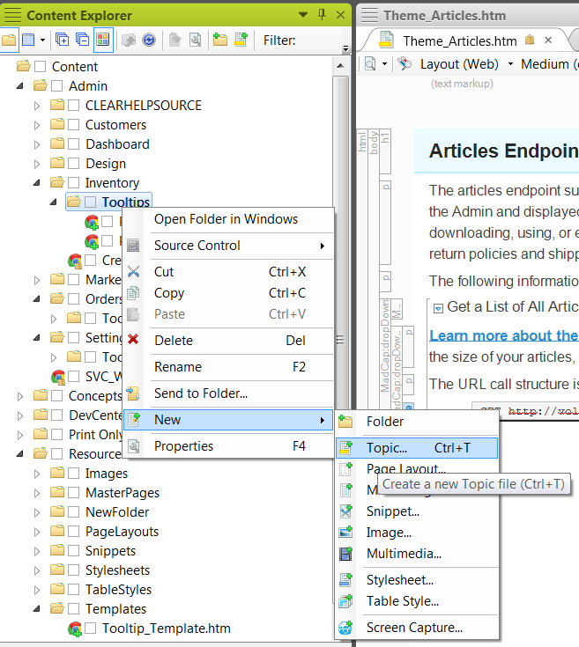

1. In the Source, scroll to the **My Templates** and choose **Tooltip_Template.htm**. Enter a **File Name** as the *page*_*field*, such as Product_Price. Click **Add**.

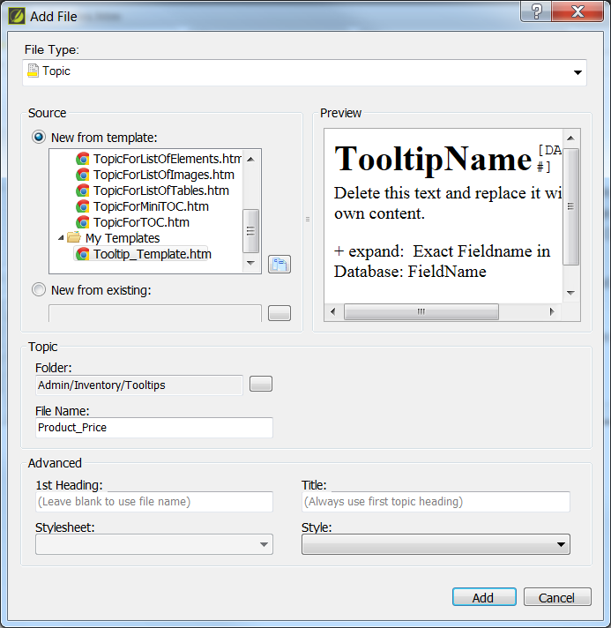

Don’t see Tooltip_Template? Do this **ONCE** for your project:

* 1. Click the little button next to **New from existing:.** This browses your computer.
  2. Browse to the Madcap Flare project file location when you imported the project. *My location in the location bar of the following screenshot will differ from yours (cause my project is in another place).* Yours may be C:\TFS\Volusion\Volusion-Flare.
  3. Browse to the following location in the project folder: **Volusion-Flare\Content\Resources\Templates** and select **Tooltip_Template.htm**.  
     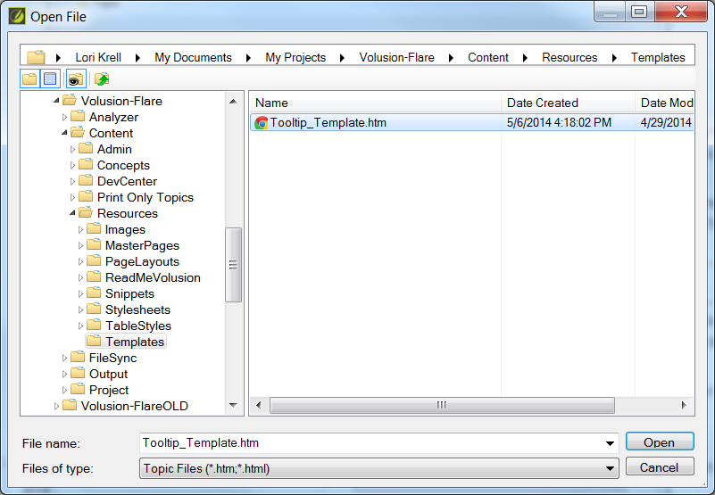
  4. Click **Open**. When back on the New Topic window will show something like this:  
     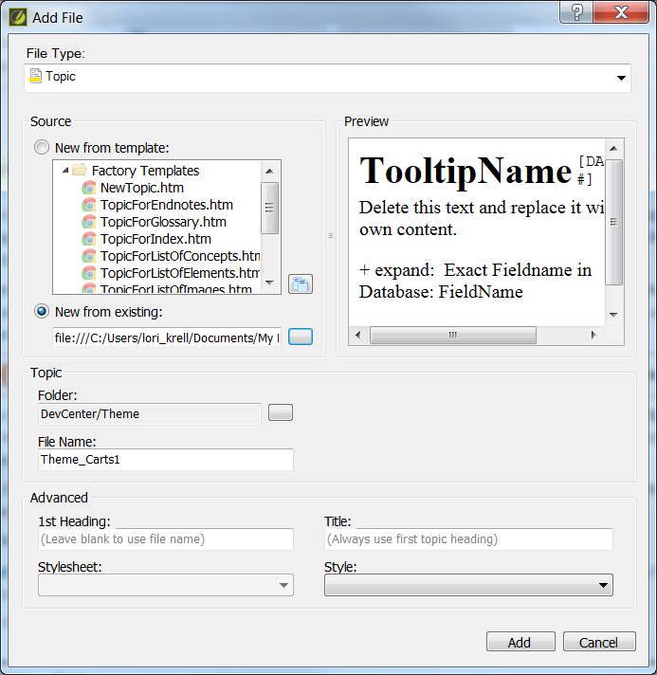
  5. Click **Add**!  
     **Note:** From now on, when you create a topic, you will see the **My Templates** in the **Source: New from Template** section.

1. A new template opens! See that H1? Right click and select delete. I can’t figure out how to remove that sucker, sorry.

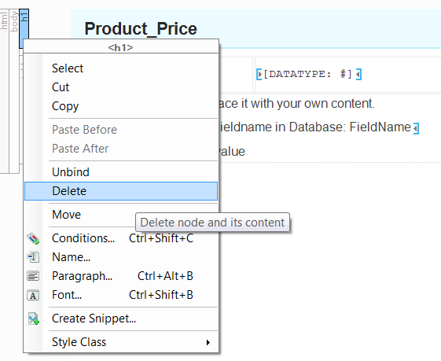

1. Now you have your template! Fill it out!

BEFORE:

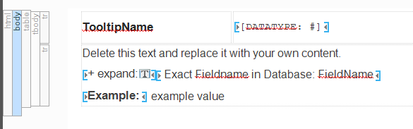

AFTER:

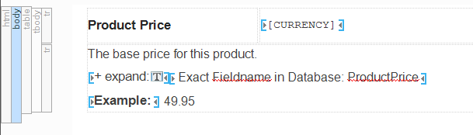

## Master Pages

With the topics created, you need to make sure they all have been assigned the proper Master Page. You can set this as you create topics or all at once with a list of multiple files.

**Note:** When you create the first, and assign the proper master page, any new topics may continue with those settings.

**Important:** If those setting continue to be used, and you need to work on other content, make sure you are using the proper master page (MasterPage.flmsp) and the Factory Topic template for those.

### Setting the Master Pager per File

1. Locate the topic you created in the Content Explorer and right click.

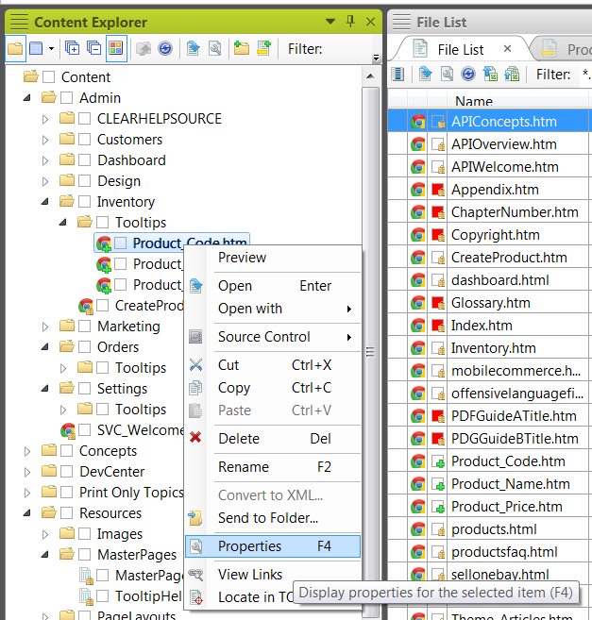

1. On the Topic Properties tab, for Topic Style Class, select **TooltipHelp**.

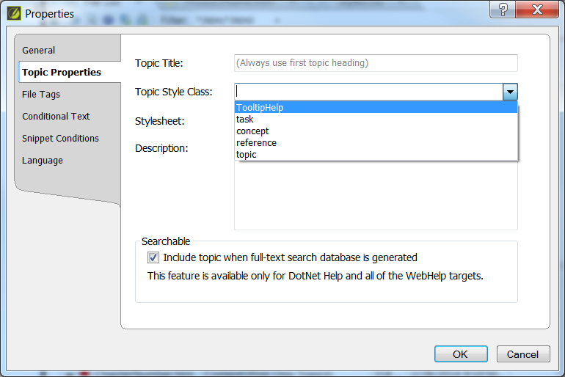

1. Click **OK**.  
   **Note:** The master page setting may “stick” when creating the next topic.

### Setting the Master Page for Multiple Files

1. Click **View** > **File List** to open the file list.

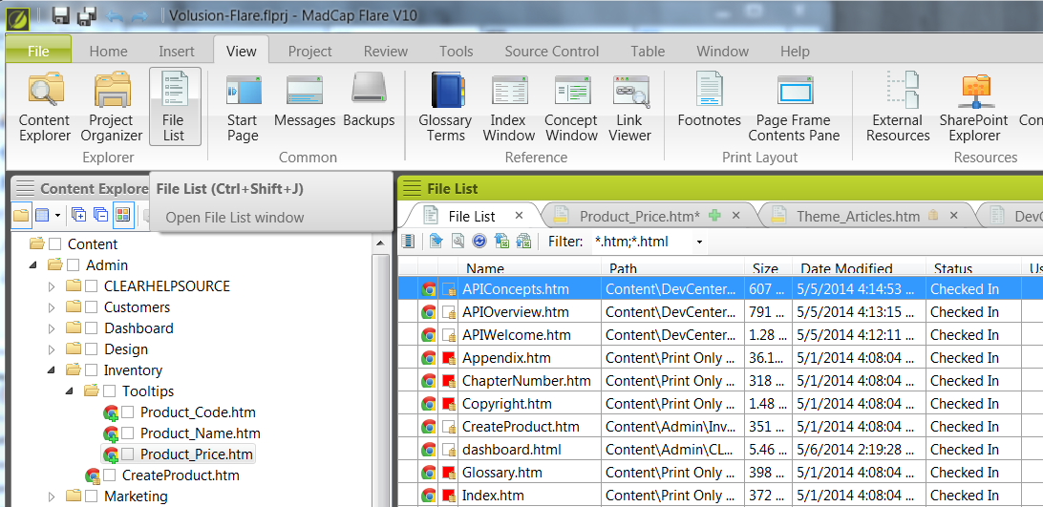

1. Select all of the topics that are in the TooltipHelp folder, right-click and select **Properties**. An easier way to locate them is to sort by path.
2. In the **Properties** dialog, click the **Topic Properties** tab. For the **Topic Style Class**, select **TooltipHelp**.



1. Click **OK** to update.

## Creating the Alias

With the topics created and master page set, you can create and assign the alias in two ways:

* Create a series of new alias entries and assign the topic to the alias.
* Create an alias per topic entry, working through the list.

This method shows you how to create one per topic.

1. Open the Project Organizer and expand **Advanced**.
2. Open the Alias tool.
3. In the Topic browser, locate a tooltip topic. Right click to select Assign topic to new Identifier.

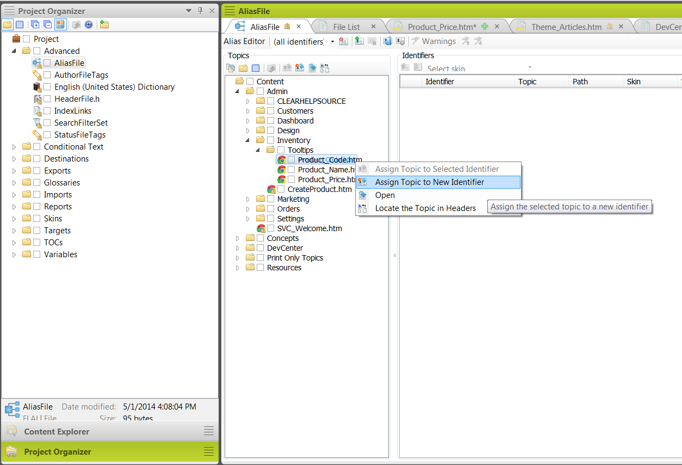

1. A new identifier displays. You can type in a name and edit the value. The value could be changed to match the current numbering scheme used for tooltips in ClearHelp/Admin.
2. After adding all of your identifiers, you can select them all, right click, and select a skin. Select TooltipHelp.

